Introduction

**Amazon Web Services** (**AWS**) is a [subsidiary](https://en.wikipedia.org/wiki/Subsidiary) of [Amazon](https://en.wikipedia.org/wiki/Amazon.com) that provides [on-demand](https://en.wikipedia.org/wiki/Software_as_a_service) [cloud computing](https://en.wikipedia.org/wiki/Cloud_computing) [platforms](https://en.wikipedia.org/wiki/Computing_platform) and [APIs](https://en.wikipedia.org/wiki/Application_programming_interface) to individuals, companies, and governments, on a metered pay-as-you-go basis. In aggregate, these cloud computing [web services](https://en.wikipedia.org/wiki/Web_services) provide a set of primitive abstract technical infrastructure and [distributed computing](https://en.wikipedia.org/wiki/Distributed_computing) building blocks and tools. One of these services is [Amazon Elastic Compute Cloud](https://en.wikipedia.org/wiki/Amazon_Elastic_Compute_Cloud), which allows users to have at their disposal a [virtual](https://en.wikipedia.org/wiki/Virtualization) [cluster of computers](https://en.wikipedia.org/wiki/Computer_cluster), available all the time1 ("Amazon Web Services About Us". Retrieved May 16, 2011)

Moreover, AWS has a lot of other services related to each sector such as Analytics, Application Integration, AR & VR, AWS Cost Management and many others. Also, It allows creating an instance for free based on low requirements

For the IoT Waterloo Job Board, We have to create MVP website based on the client’s requirements with minimal cost. In order to manage the budget, we have used Amazon Web Service EC2(Elastic Cache) **Windows Server 2012 R2** free instance to host the website

**Followings are the steps with screenshots to create AWS EC2 instance and Hosting the website in that instance**

1. Login to AWS account with credentials (If you do not have an account create one)

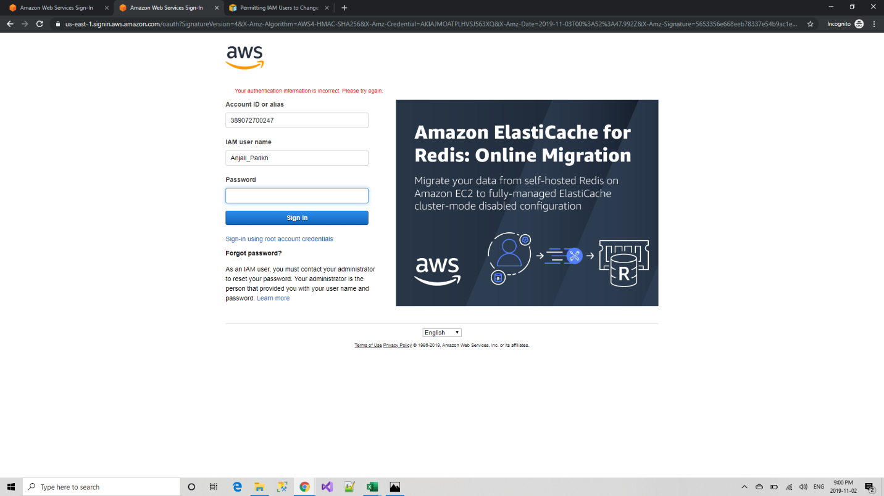

1. Click on Services tab on the top left and select EC2 under the Compute section

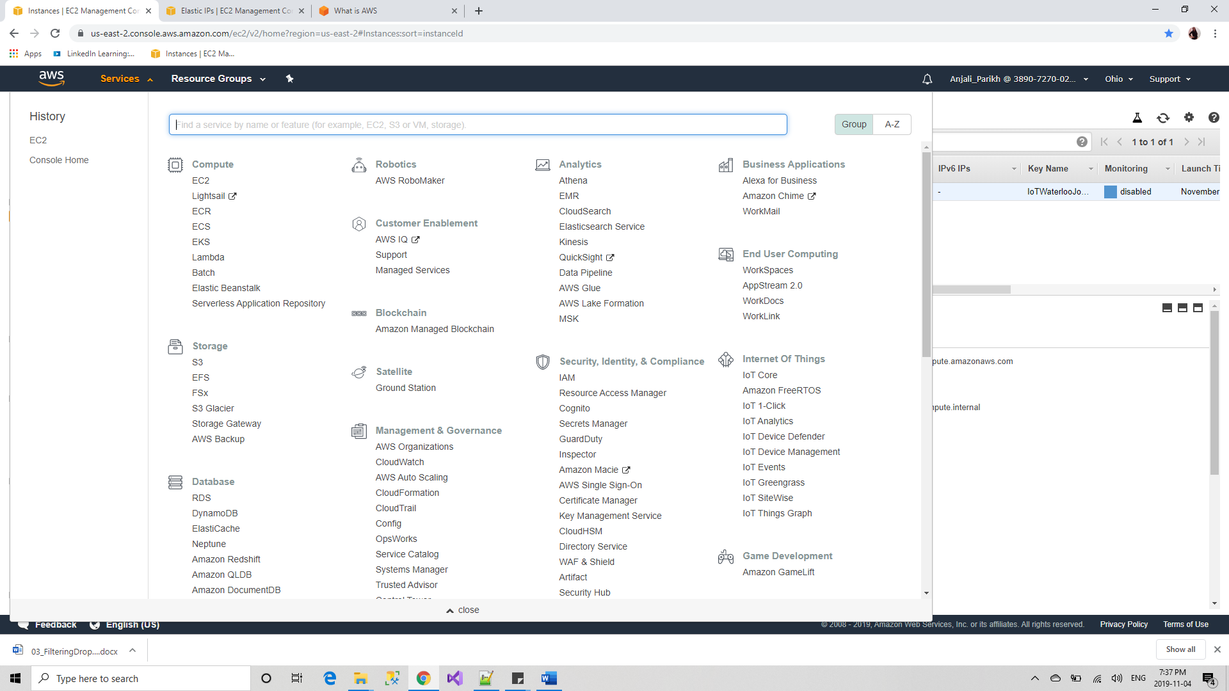

1. Click on Launch Instance

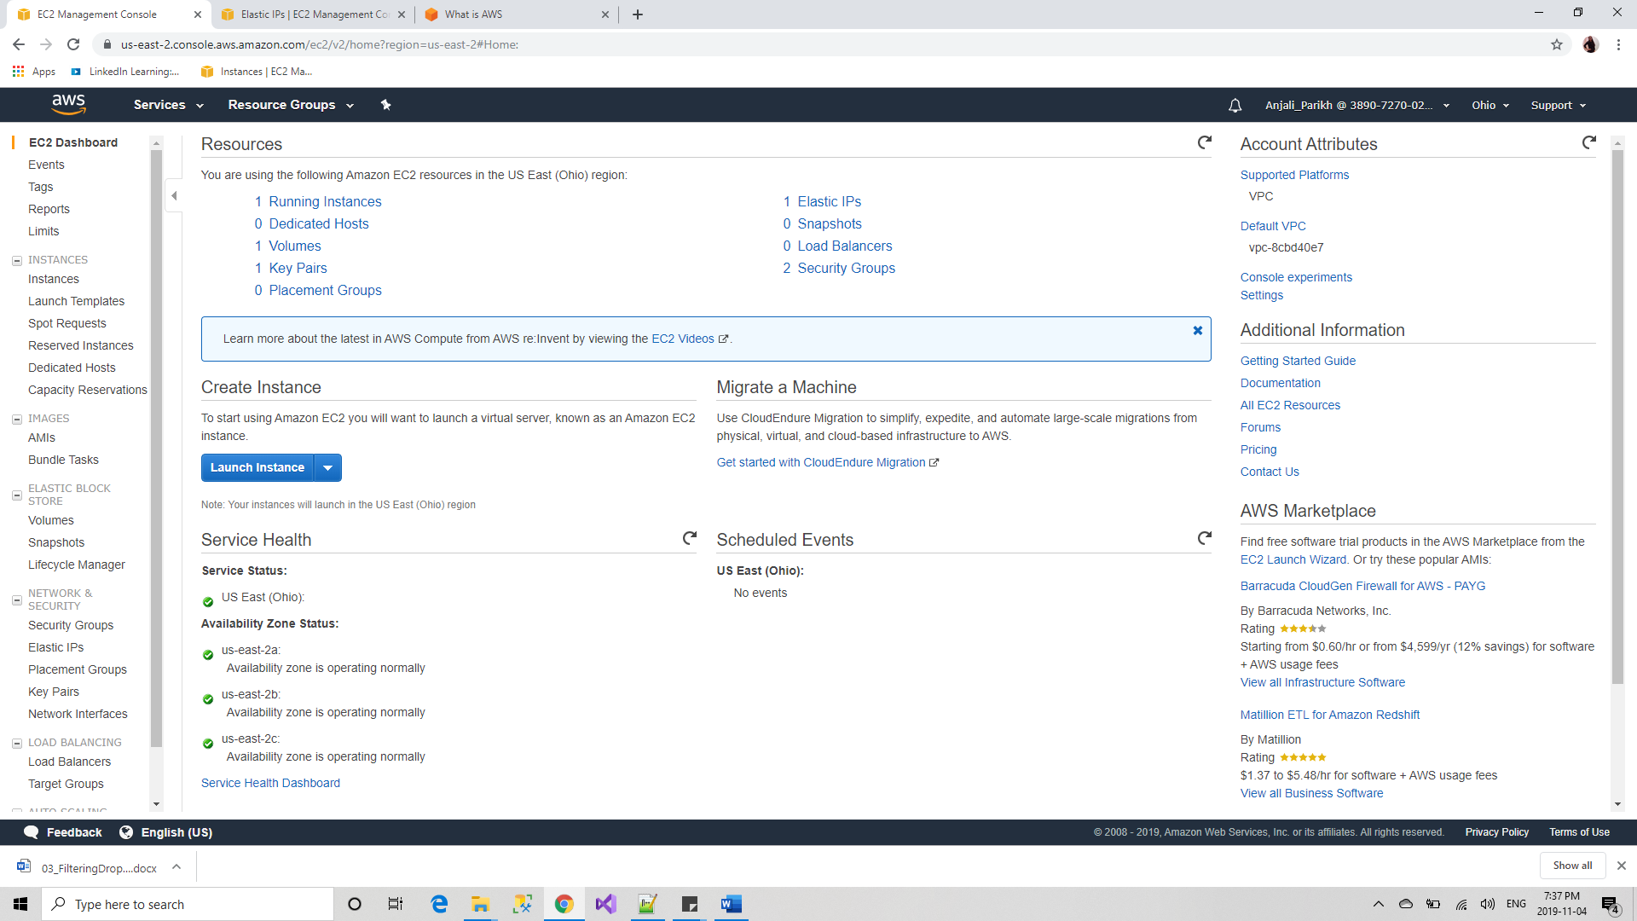

1. Find Microsoft Windows Server 2012 R2 Base and click on Select

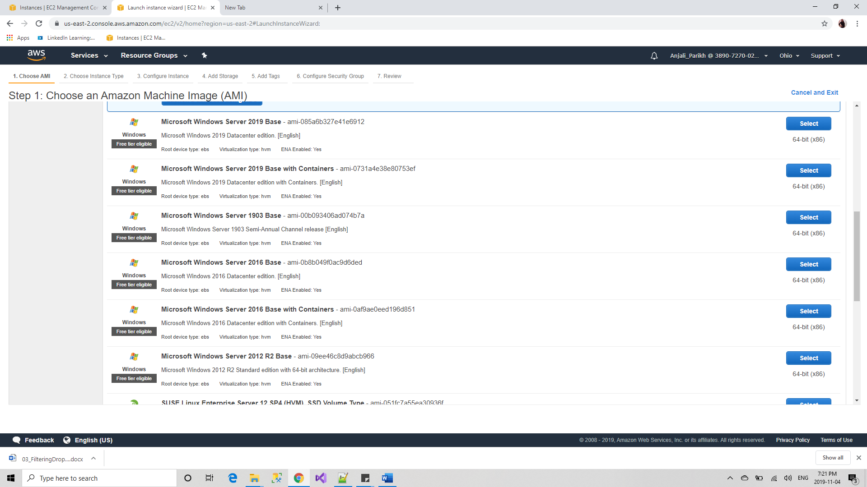

1. Select the instance size and other configuration as required

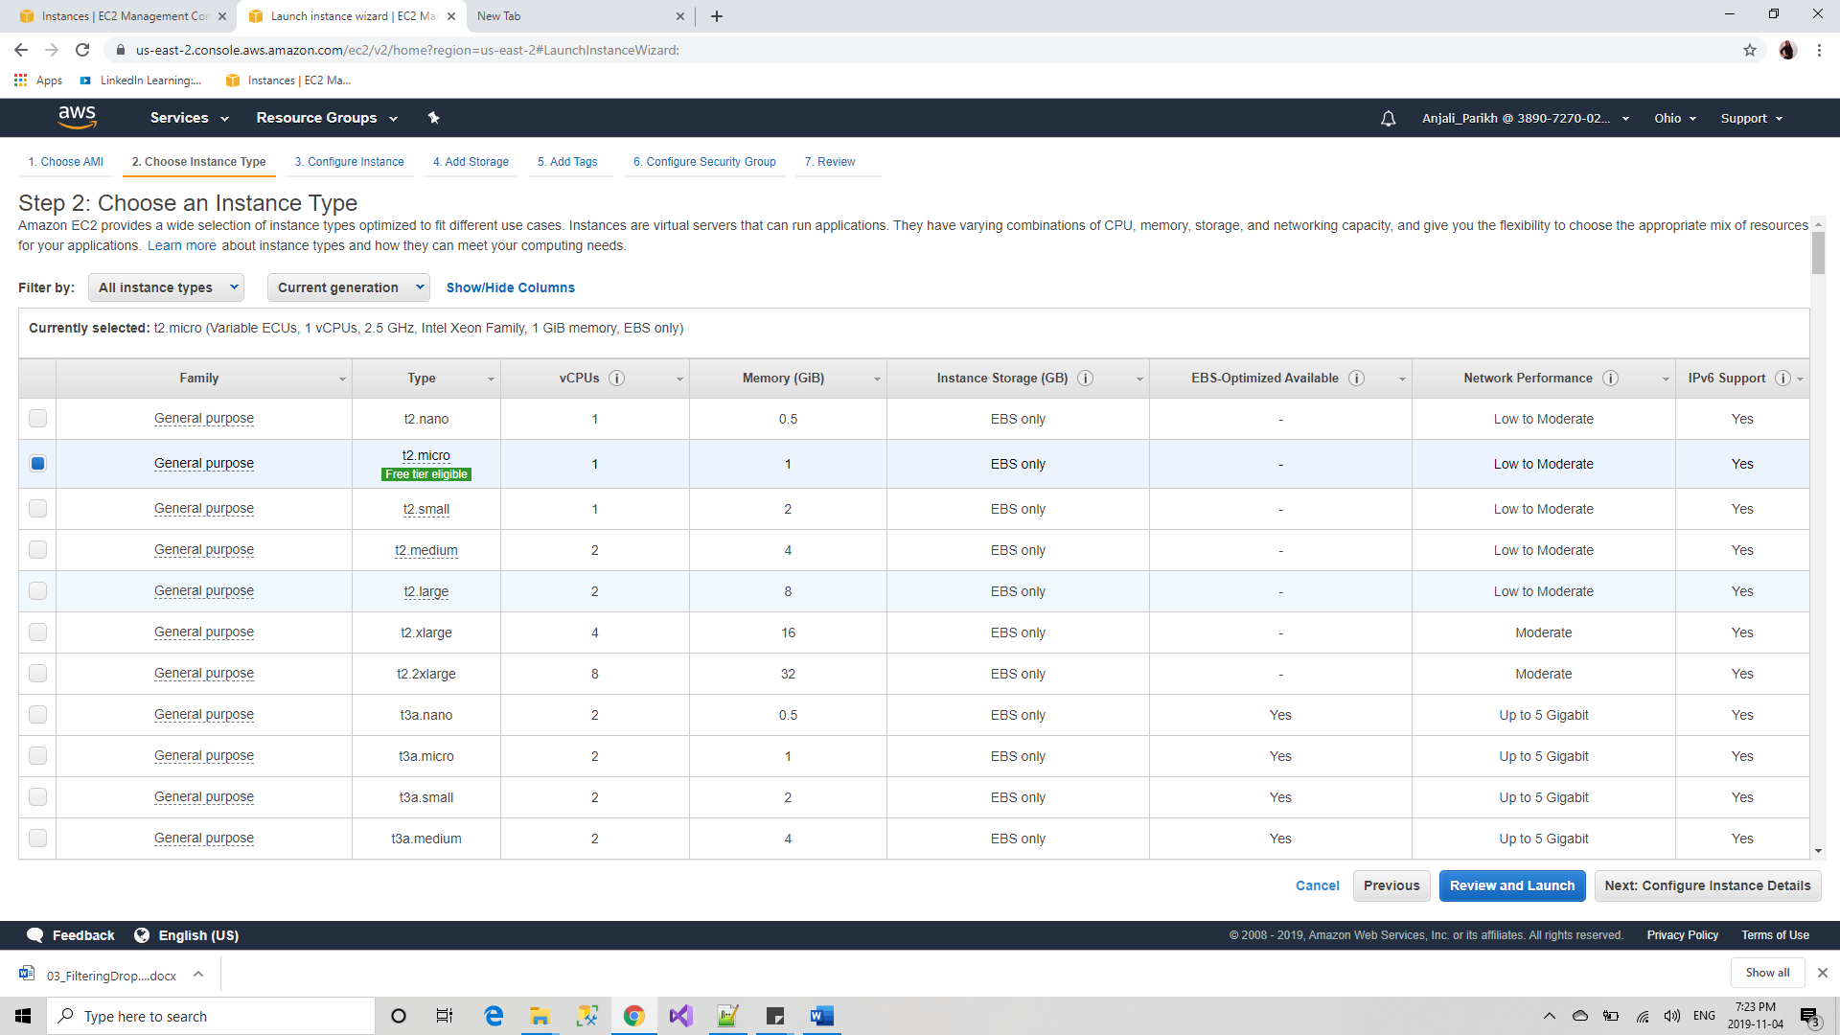

1. Review and modify default configuration details if required

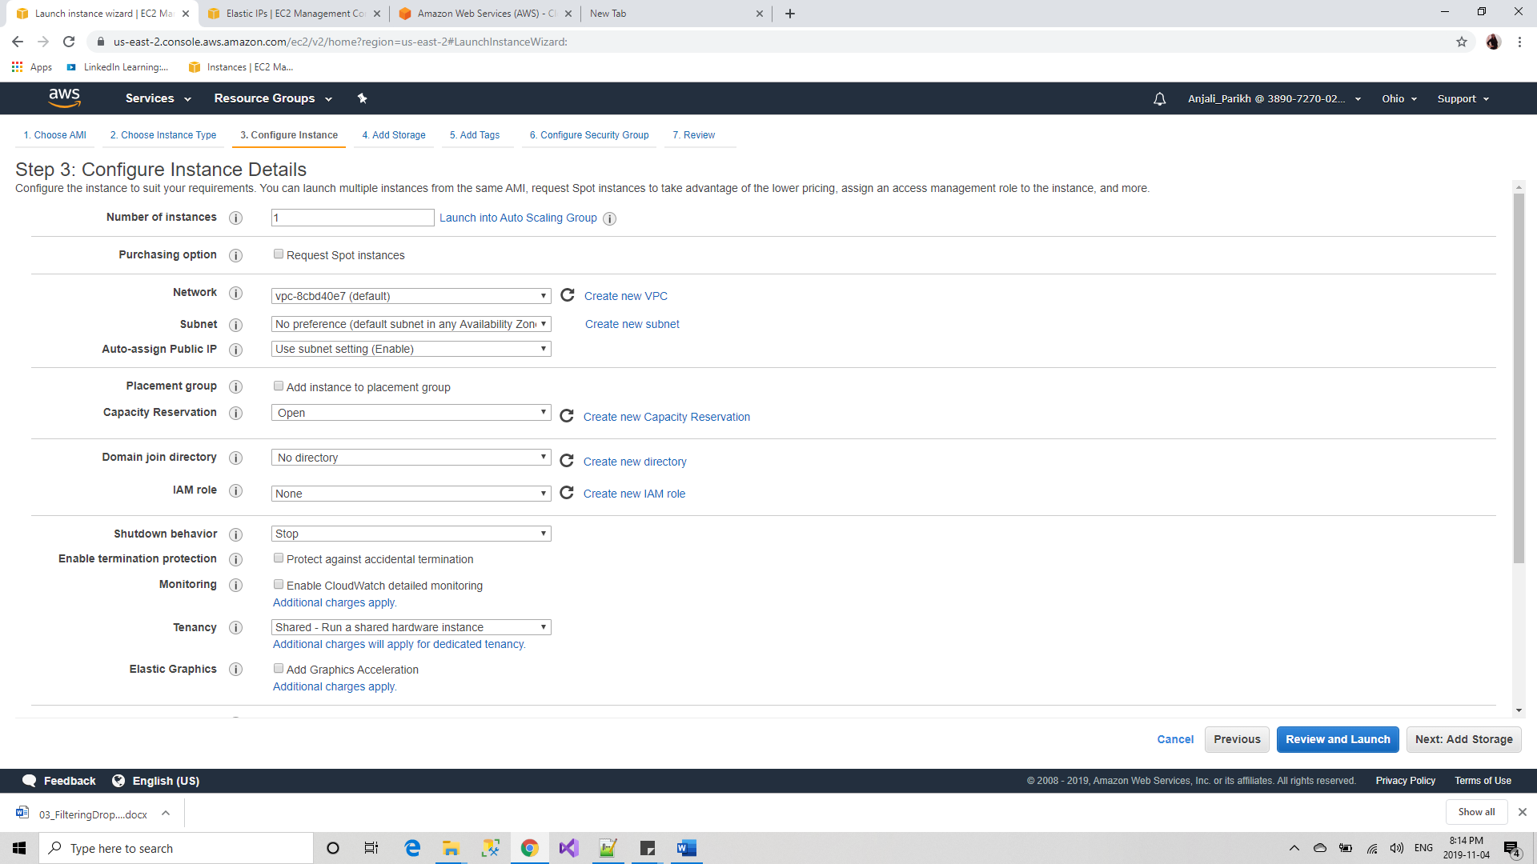

1. Modify default storage size if required

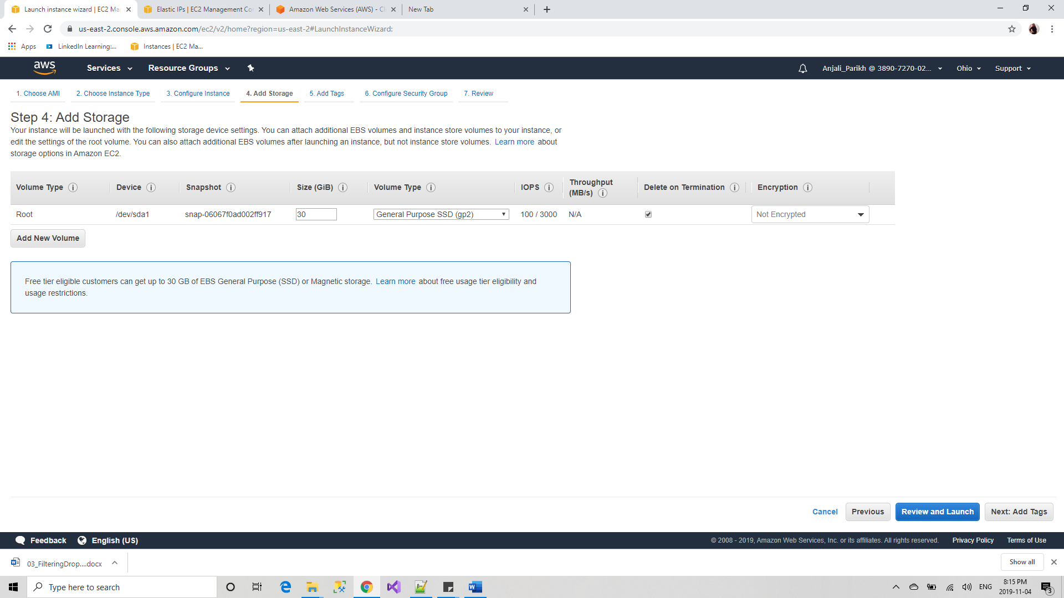

1. Add tags if needed

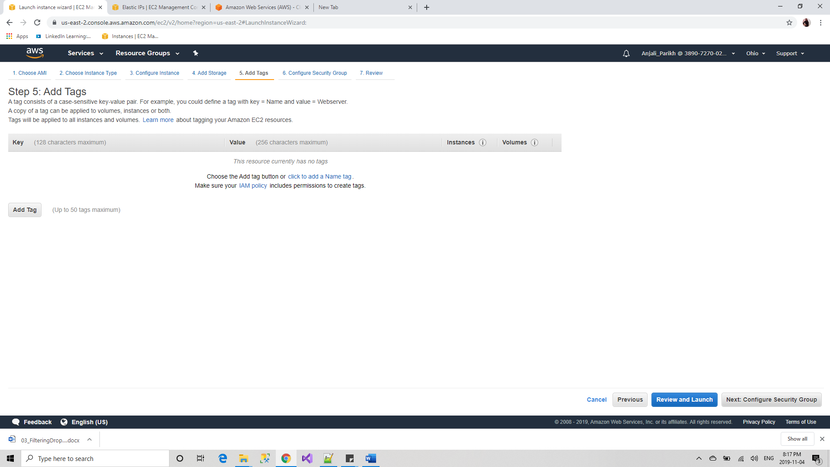

1. Review details and click on Lunch

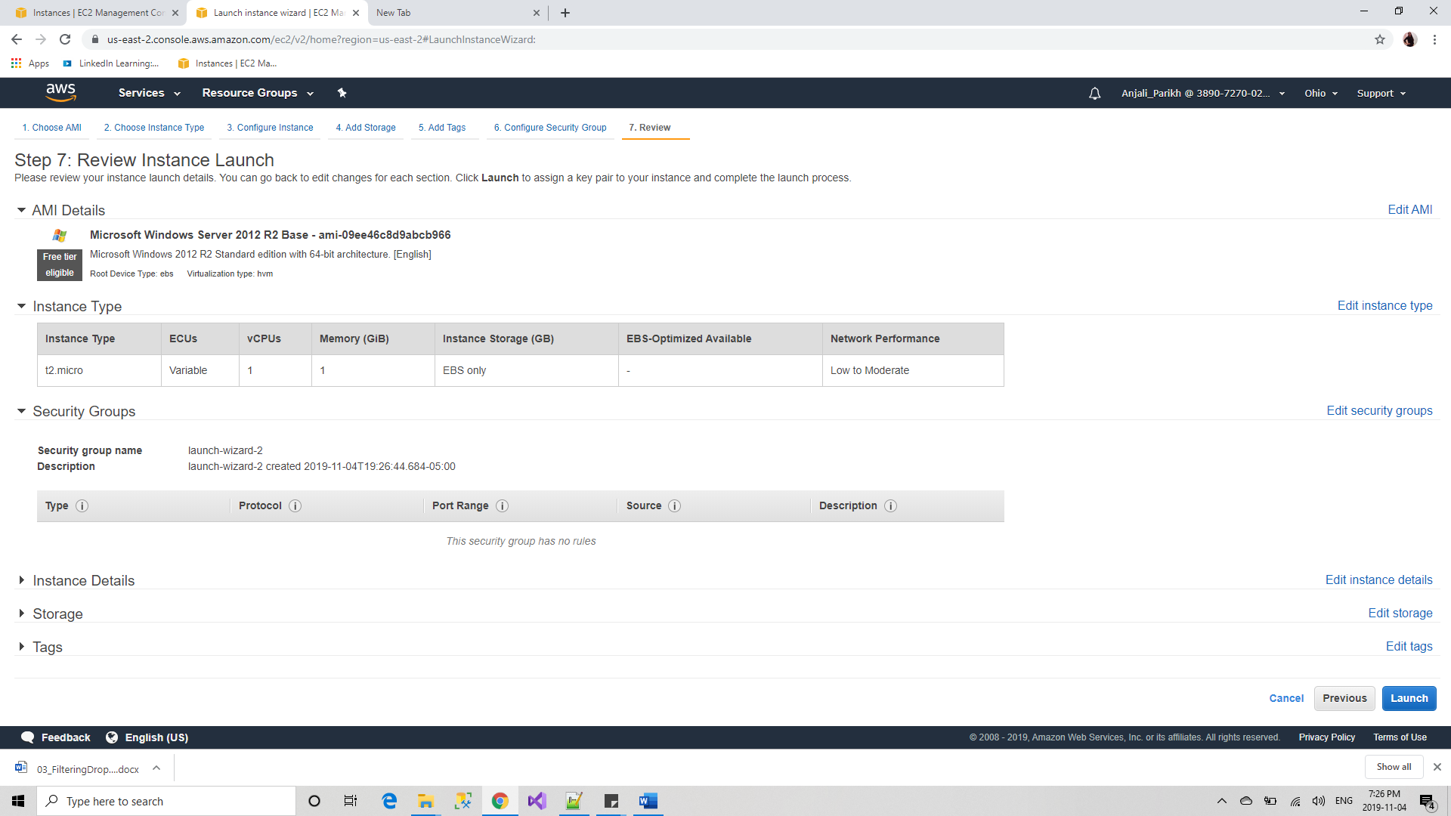

1. You will find the recently created instance and it is running

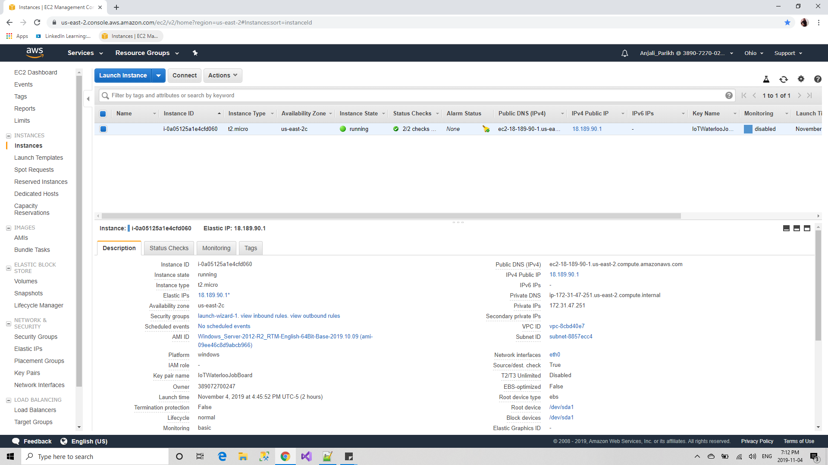

1. Use Elastic IP for associate Ip address of create instance

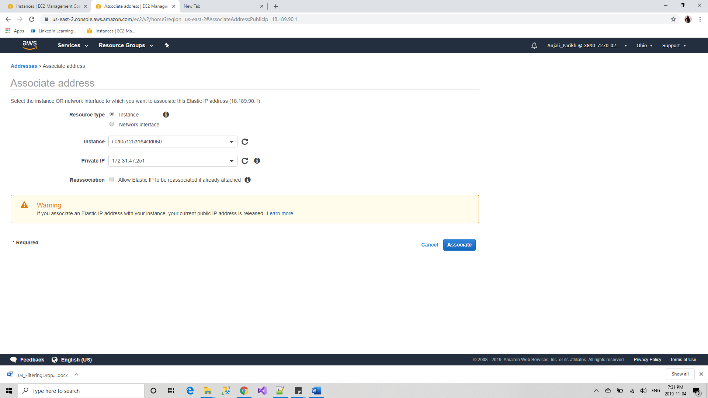

Now as instance is created, we can use it for hosting the website.

**Followings are steps to host website.**

1. Install IIS in Microsoft Windows Server 2012 R2 Base Instance. Open Server Manager and click on add roles and features

1. Click Next

1. Select Role-based or feature-based installation and click Next

1. From the Server Seletion choose Select a server from the server pool and Select NextA screenshot of a social media post

   Description automatically generated
2. Select web Server cofigurations and click on NextA screenshot of a cell phone

   Description automatically generated
3. Select .Net Frameworks which your website required and click on InstallA screenshot of a cell phone

   Description automatically generated
4. After Installtion succeded, Open IIS and right click on Sites and click on Add Website.A screenshot of a cell phone

   Description automatically generated
5. Add Site name, Physical path of the published website folder and select Binding details and click OK.A screenshot of a cell phone

   Description automatically generated
6. You will see the website is created and hosted in IIS

Now you can use this website from any machine by using domain name or IP address of this machine

For the IoT Waterloo Job Board is hosted and can be access using URL: <http://ec2-18-189-90-1.us-east-2.compute.amazonaws.com/>

# Bibliography

"Amazon Web Services About Us". Retrieved May 16, 2. (2011, September ). *https://en.wikipedia.org/wiki/Amazon_Web_Services*. Retrieved from https://en.wikipedia.org: https://en.wikipedia.org/wiki/Amazon_Web_Services